INDEX

Sl10 No | Name of the program | Date | Page No | Remarks
1 | Create your class time table using table tag. |  | 2
2 | Design a web Page for your college containing description of courses, department, faculties, library etc. Using list tags, href tags and anchor tags. |  | 4
3 | Create Your Resume using HTML.Use text, link, lists. |  | 8
4 | Create a Web Page of a Supermarket using internal CSS. |  | 10
5 | Use Inline CSS to format your resume that you have created. |  | 13
6 | Use External CSS to format your time table created. |  | 15
7 | Use all the CSS (inline,internal and external) to format the college website that you have created. |  | 18
8 | Writw a HTML code to create your college website fot Mobilr devices. |  | 22
9 | Write an JavaScript/HTML page to create a login page with validations.

Program 1
Create class time table using table tag

Aim
Create a html page to display class time table

Program
<!DOCTYPE html>
<html>
<head>
<title>Time Table</title>
</head>
<body>
<h1>TIME TABLE</h1>
<table border="1">
<tr>
<th></th>
<th>HOUR 1</th>
<th>HOUR 2</th>
<th>HOUR 3</th>
<th>HOUR 4</th>
<th>HOUR 5</th>
</tr>
<tr>
<th>DAY 1</th>
<th>DS</th>
<th>OS</th>
<th>English</th>
<th>Web lab</th>
<th>Web lab</th>

</tr>
<th>DAY 2</th>
<th>Hindi</th>
<th>OS</th>
<th>IC</th>
<th>Maths</th>
<th>DS</th>
</tr>
<tr>

<th>DAY 3</th>
<th>English</th>
<th>DS</th>
<th>Web</th>
<th>Hindi</th>
<th>Maths</th>
</tr>
<tr>
<th>DAY 4</th>
<th>Maths</th>
<th>DS</th>
<th>OS</th>
<th>DS lab</th>
<th>DS lab</th>

</tr>
<tr>
<th>DAY 5</th>
<th>Maths</th>
<th>OS</th>
<th>IC</th>
<th>Hindi</th>
<th>Web</th>

</tr>

</table>

</body>
</html>

Output
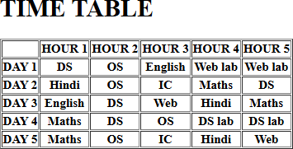

Program 2
Design a web Page for your college containing description of courses, department, faculties, library ect. Using list tags, href tags and anchor tags.

Aim
Design a web Page for your college containing description of courses, department, faculties, library etc. Using list tags, href tags and anchor tags.

Program

<!DOCTYPE html>
<html>
<head>
<title>St George College</title>
</head>
<body>
<h3 align="center"><img src="sgc-college.png" width="150"></h3>
<h1 align="center" width="20">St. George's College Aruvithura</h1>

<p></p>

<p>

St. George's College, Aruvithura (Kottayam), is an A++ NAAC-accredited, MG University- affiliated institution offering>
Key Undergraduate Courses (UG)

<div>
<ul>
<li>B.Sc. (Honours): Food Science & Quality Control (Specialization in Food Safety), Botany, Chemistry, Mathe>
<li> B.Com (Aided & Self-Financing): B.Com Computer Applications, B.Com Honours

(Financial Markets & Logistics/Co->
<li> B.A. (Aided & Self-Financing): English with Teaching, Political Science.</li>
<li>Vocational & Other: B.Voc Food Technology & Analysis.</li>
</ul>
Key Postgraduate Courses (PG)
<ul>
<li>M.Sc.: Physics, Chemistry, Food Technology & Quality Assurance.</li>
<li>Integrated M.A.: English (5-year programme).</li>
</ul></p>
<h3>Departments</h3>
<p>
<ul>
<li>English</li><li> Mathematics</li><li> Physics</li><li> Chemistry</li><li> Botany</li><li> Zoology</li><li> Commer>

</ul></p>

<h3>Courses</h3>
<h5>Aided</h5>
<ol>
<li>B.Sc (Honours) Mathematics </li>

<li>B.Sc (Honours) Physics</li>

<li>B.Sc (Honours) Chemistry</li>

<li>B.Sc (Honours) Botany</li>

<li>B.A (Honours) Economics </li>
<li>B.A (Honours) Political Science </li>

<li>B A (Honours) English with Specialization in Media Studies & Film Studies </li>

<li>B.Com (Honours) with Specialization in Finance & Taxation</li>

<li>BCA (Honours) with Specialization in Data Science & Full Stack Development</li>
</ol>

<h3>Library</h3>

<p>

The library at St. George's College, Aruvithura, has a rich history, having started functioning in 1965. Over the yea>

<div>Today, the library has a vast collection of resources to support the academic programs of the college. There are>

<p>In addition to the regular collection, the library also provides resources specifically for academic support progr>
</p>

</p>

<h3>Faculty</h3>
Key Faculty and Departments
<ul>
<li> Principal: Dr. Siby Joseph.</li>
<li> English: Smt. Thejimol George, Smt Sherin Elizabeth John.</li>
<li> Mathematics & Statistics: Smt. Sheelamma George.</li>
<li> Physics: Dr. Sumesh George.</li>
<li> Chemistry: Smt. Ansamma Thomas.</li>
<li> Commerce: Sri. Josiah John.</li>
<li> Politics & History: Dr. Regi Varghese Mekkaden</li>
<li> Zoology: Smt Agnes Clara K Veedon.</li>
<li> Physical Education: Dr. Sunny V Zacharias.</li>
<li> Food Science & Technology: Faculty members including Smt. Akhila M P.</li>
<li> Computer Applications (Aided):Dr. justin Joy</li>
<ul>

<h1 align="center">About</h1>
<p>St. George's College Aruvithura is a college under Mahatma Gandhi University, Kottayam. It is located in Aruvithur>
St. George’s College Aruvithura, is a minority educational institution founded by St. George Forane Church, Aruvithur>

<p>Currently, the college offers 17 undergraduate courses, and 5 postgraduate courses and the Department of Chemistry>
<p><h4 align="center"><a href="sgcaruvithura.in">sgcaruvithura.in</a></h4>
</p<h3 align="center"><img src="sgc-college.png" width="500"></h3>
</body>
</html>
>

Output
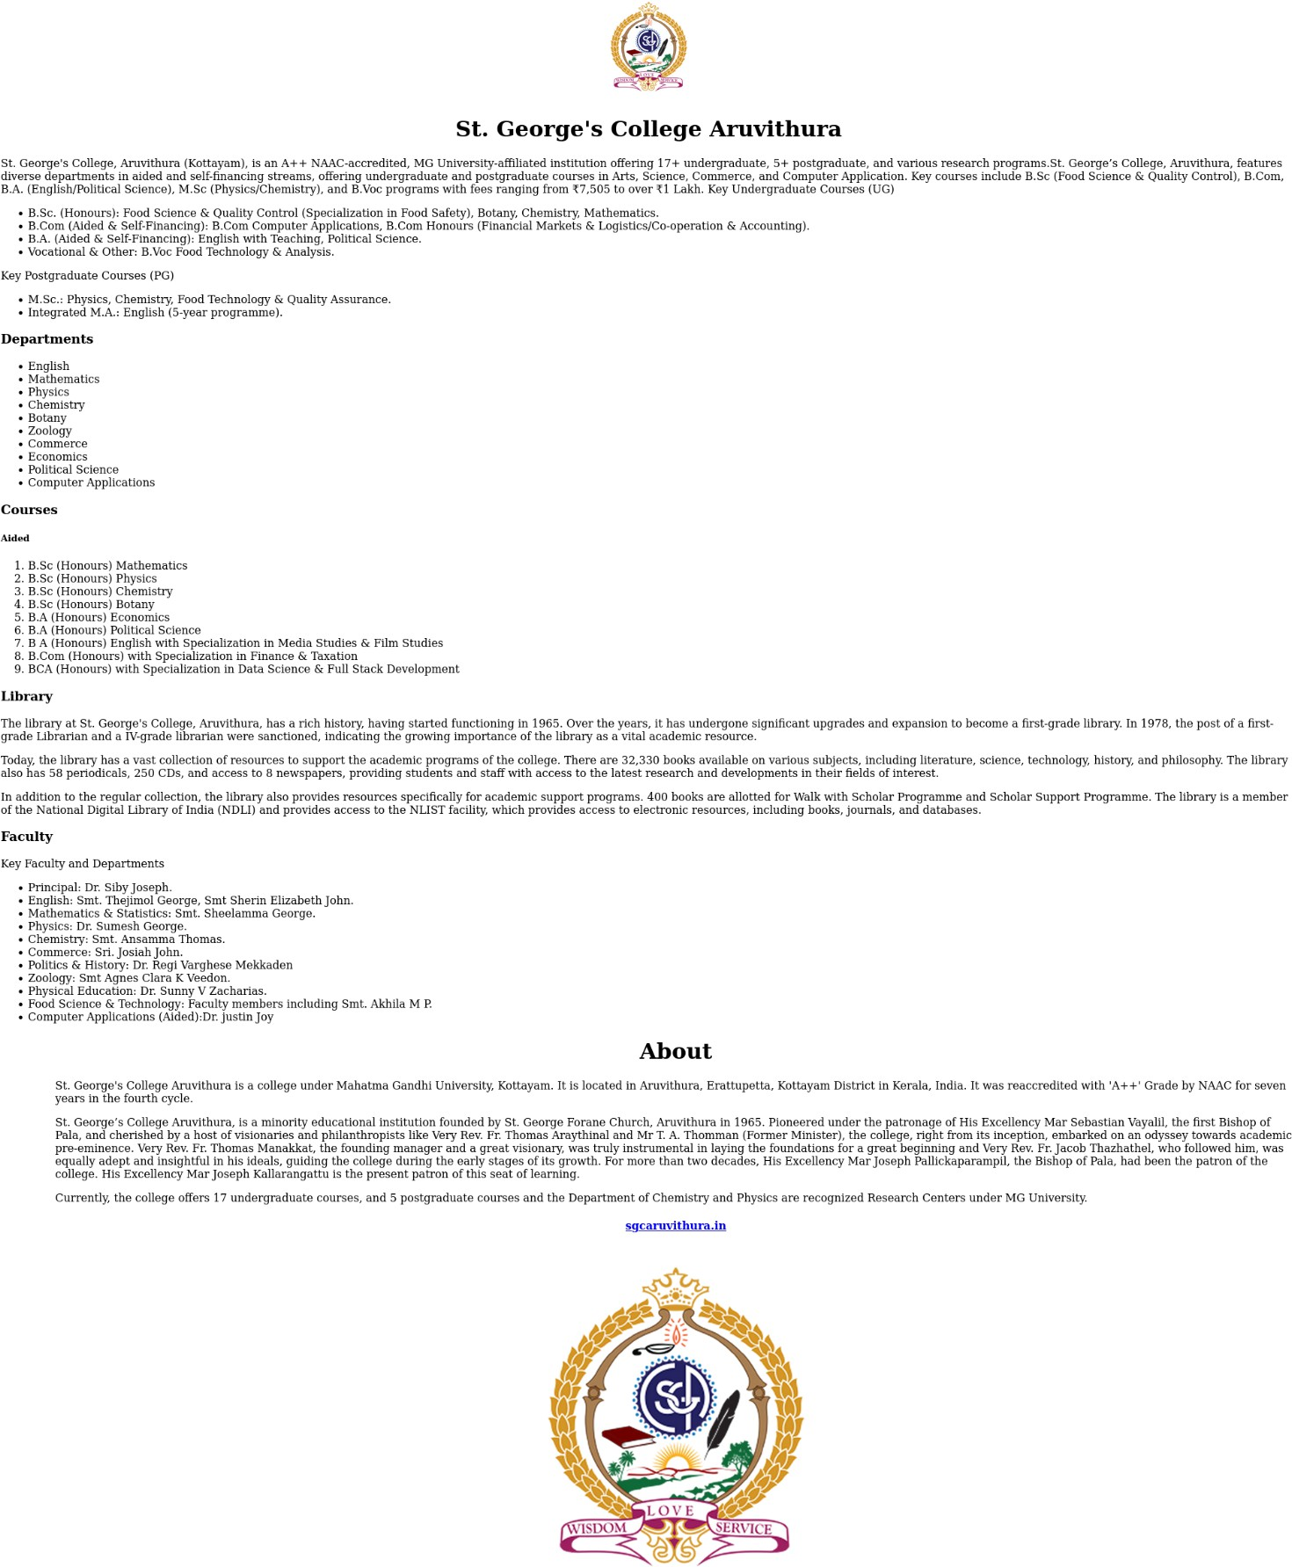

Program 3
Create Your Resume using HTML.Use text, link, lists.

Aim
Create Your Resume using HTML.Use text, link, lists.

Program

<!DOCTYPE html>
<html>
<head>
<title>Resume</title>
</head>
<body>
<div padding="20px">
<h1 align="center">LIS MARIA GEORGE</h1>
<p align="center">lismariageorge123@gmail.com<br></br>+91 9234567890</p>
<h3>CERTIFICATE</h3>
<ul>
<li>cs50</li><a href="cs50">cs50</a>
<li>IBM front-end,back-end JacaScript </li><a href="ibm">ibmfrontendbackendjavascript</a>
</ul>
<h3>EDUCATION</h3>
<ul>
<li><div>BCA </div><div> St.George's College Aruvithura , 2025-29</li>
<li>+2 <div> Govt. Higher Secondary School Poomala ,2023-25</li>
<li>10th <div> Govt. Higher Secondary School Poomala,2023</li>

</ul>
<h3>SKILL</h3>
<ul>
<li>Programming</li>
<li>Webpage creating</li>
</ul>
<h3>LANGUAGE KNOWN</h3>
<ul>
<li>C</li>
<li>HTML</li>
<li>CSS</li>

</ul>
<h3>EXPERIENCE</h3>
<ul>
<li>Internship, WIPRO Compamy</li>

</ul>
</div>
</body>
</html>

Output

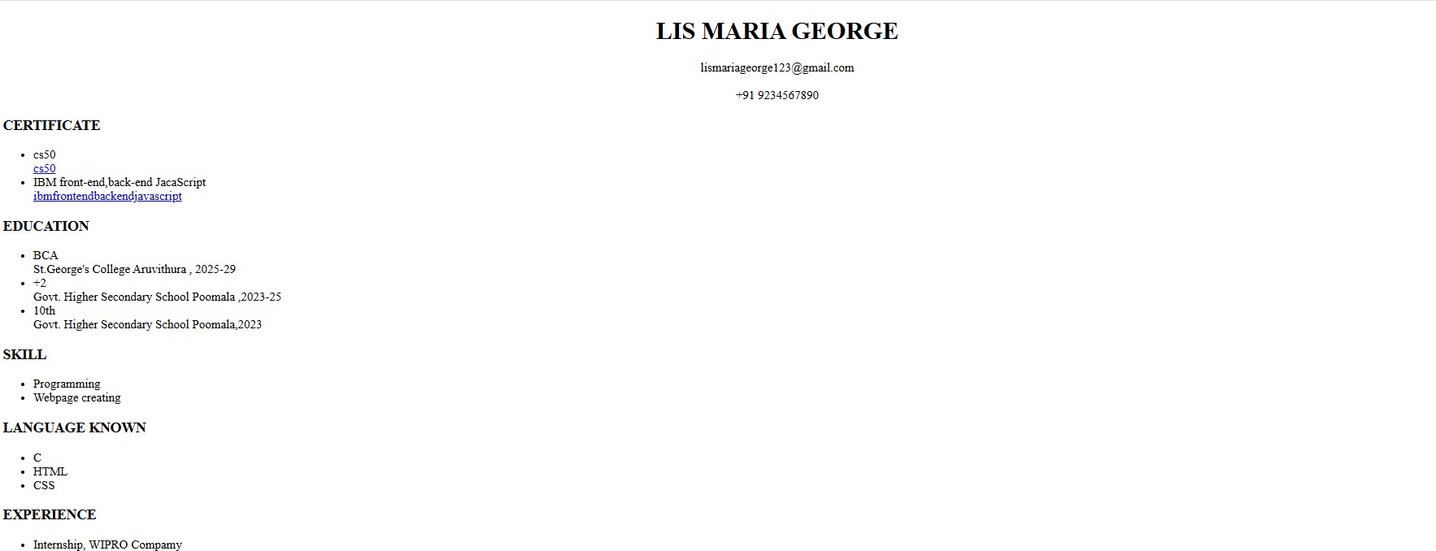

Program 4
Create a Web Page of a Supermarket using internal CSS.

Aim
Create a Web Page of a Supermarket using internal CSS.

Program
<!DOCTYPE html>
<html>
<head>
<title>Supermarket</title>
<style> h1{
text-align:center; color:green;
}
.heading{
color:red;

font-family:arial,sans-serif;
}
.points{
color:blue;
}
div{
margin:20px;
}
div[id="2"]{
padding:;
}

</style>
</head>
<body>
<h1>SUPERMARKET</h1>
<div id="1">
<div>
<h3 class="heading">FRUITS</h3>
<ul class="points">
<li>Apple</li>
<ul>
<li>Green Apple</li>

</ul>
<li>Orange</li>
<li>Grapes</li>
<li>Strawberry</li>
<li>banana</li>
<ul>
<li>Ripe Banana</li>
<li>Raw Banana</li>
</ul>
</ul>
<br></br>
<div>
<h3 class="heading">JUICES</h3>
<ul class="points">
<li>Mango Juice</li>
<li>Orange Juice</li>
<li>Watermelon Juice</li>
<li>Limejuice</li>
</ul>
</div>
<br></br>
</div>
<div id="2">
<h3 class="heading">BAKETY ITEMS</h3>
<ul class="points">
<li>Buiscuts</li>
<ul>
<li>Oreo</li>
<li>Hide & seek</li>
</ul>
<li>Chips Items</li>
<ul>
<li>Potato chips</li>
<li>Banana chips</li>
</ul>
</ul>
<br></br>
<h3 class="heading"> VEGETABLES</h3>
<ul class="points">
<li>Tomato</li>
<li>Potato</li>
</ul>
</div>
</div>
</body>
</html>

Output

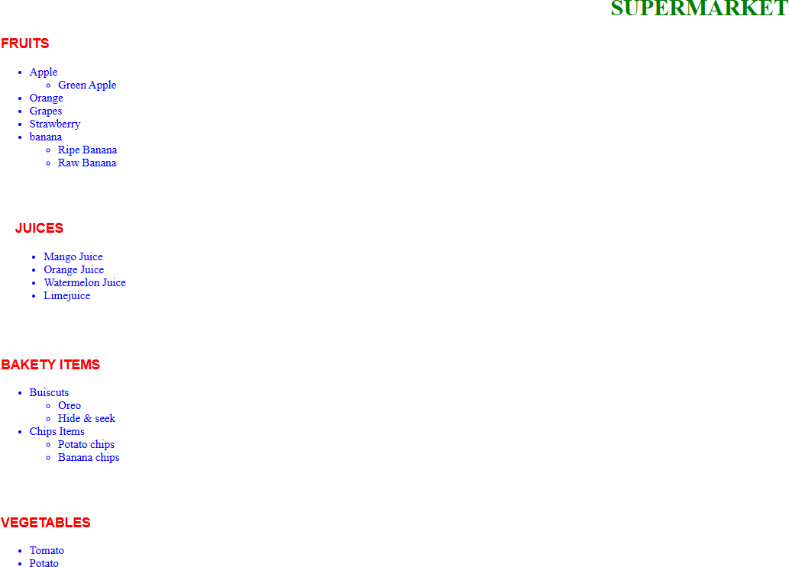

Program 5
Use Inline CSS to format your resume that you have created.

Aim
Use Inline CSS to format your resume that you have created.

Program
<!DOCTYPE html>
<html>
<head>
<title>Resume</title>
</head>
<body>
<div id="div">
<h1 align="center">LIS MARIA GEORGE</h1>
<p align="center" id="email"><strong>lismariageorge123@gmail.com<br></br>+91 9234567890</strong>
</p>
<h3 style=" font-family:arial,sans-serif;padding:10px;">CERTIFICATE</h3>
<ul style="margin:30px;">
<li>cs50</li><a href="cs50">cs50</a>
<li>IBM front-end,back-end JacaScript </li><a href="ibm">ibmfrontendbackendjavascript</a>
</ul>
<h3 style=" font-family:arial,sans-serif;padding:10px;">EDUCATION</h3>
<ul style="margin:30px;">
<li><div>BCA </div><div> St.George's College Aruvithura , 2025-29</li>
<li>+2 <div> Govt. Higher Secondary School Poomala ,2023-25</li>
<li>10th <div> Govt. Higher Secondary School Poomala,2023</li>

</ul>
<h3 style=" font-family:arial,sans-serif;padding:10px;">SKILL</h3>
<ul style="margin:30px;">
<li>Programming</li>
<li>Webpage creating</li>
</ul>
<h3 style=" font-family:arial,sans-serif;padding:10px;">LANGUAGE KNOWN</h3>
<ul style="margin:30px;">
<li>C</li>
<li>HTML</li>
<li>CSS</li>

</ul>
<h3 style=" font-family:arial,sans-serif;padding:10px;">EXPERIENCE</h3>
<ul style="margin:30px;">
<li>Internship, WIPRO Compamy</li>

</ul>
</div>
</body>
</html>

Output

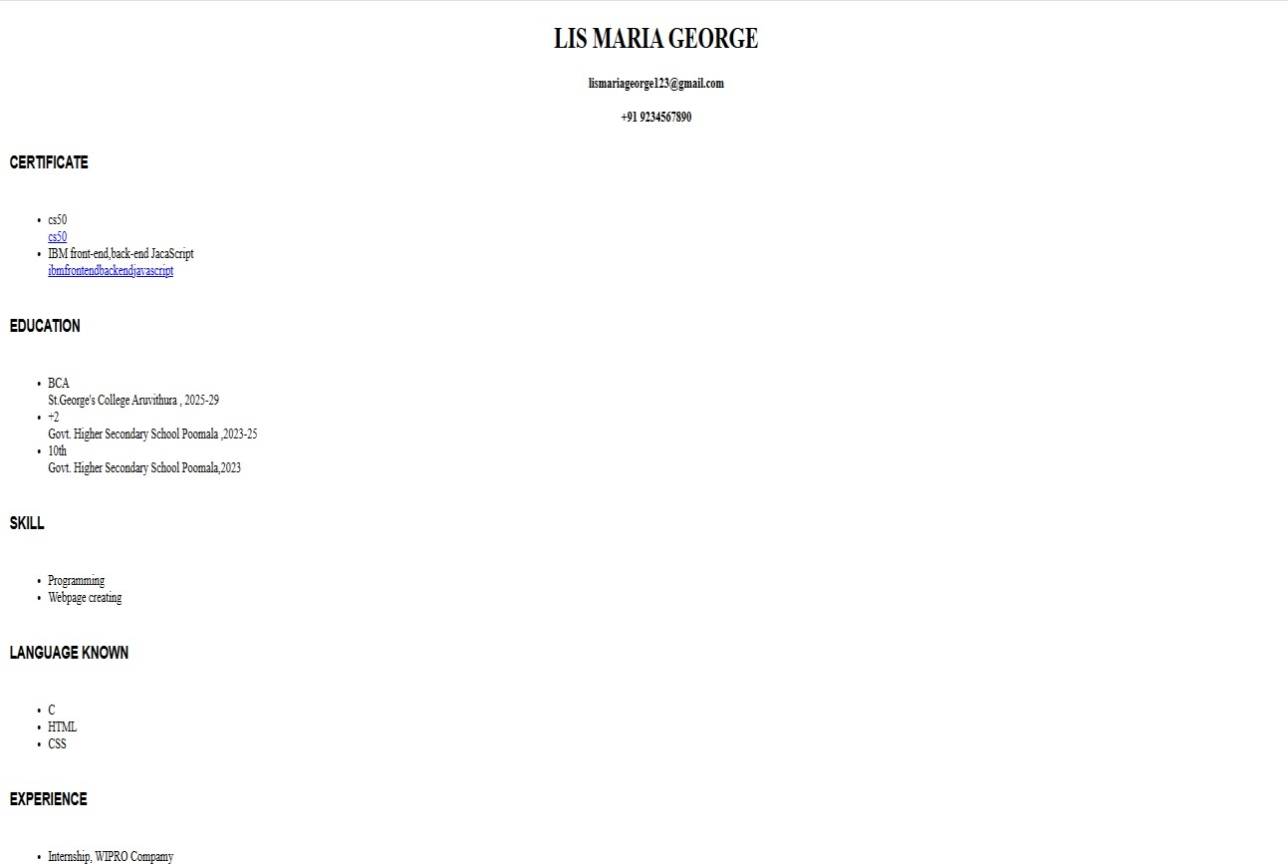

Program 6
Use External CSS to format Your time table created.

Aim
Use External CSS to format Your time table created.

Program
#<!DOCTYPE html>
<html>
<head>
<title>External css time table</title>
<link rel="stylesheet" href="time_table.css">
</head>
<body>
<table border="3">
<h1 id="heading">TIME TABLE</h1>
<tr id="fr">
<th class="day"> </th>
<th>HOUR 1</th>
<th>HOUR 2</th>
<th>HOUR 3</th>
<th>HOUR 4</th>
<th>HOUR 5</th>
</tr>

<tr class="row">
<th class="day">DAY 1 </th>
<td>DS</td>
<td>OS</td>
<td>English</td>
<td>Web lab</td>
<td>Web lab</td>
</tr>
<tr class="row">
<th class="day">DAY 2</th>
<td>Hindi</td>
<td>OD</td>
<td>IC</td>
<td>Maths</td>

<td>DS</td>
</tr>
<tr class="row">
<th class="day">DAY 3</th>
<td>English</td>
<td>DS</td>
<td>Web</td>
<td>Hindi</td>
<td>Maths</td>
</tr>
<tr class="row">
<th class="day">DAY 4</th>
<td>Maths</td>
<td>DS</td>
<td>OS</td>
<td>DS lab</td>
<td>DS lab</td>
</tr>
<tr class="row">
<th class="day">DAY 5</th>
<td>Maths</td>
<td>OS</td>
<td>IC</td>
<td>Hindi</td>
<td>Web</td>
</tr>
</body>
</html>

time_table.css

#heading{
color:blue; width:23cm;
text-align:center;
font-family:arial,sans-serif;

}
.day{

}
#fr{

}

text-align:center; background-color:pink;

background-color:pink;

.row{
text-align:center;
}
table{
margin:57px; width:20cm;

background-color:yellow; text-align:center; border:2px solid black;
}

Output

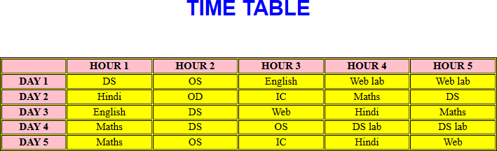

Program 7
Use all the CSS (inline,internal and external) to format the college web page
that you have created.

Aim
Use all the CSS (inline,internal and external) to format the college web page that you have created.

Program
<!DOCTYPE html>
<html>
<head>
<title>St George College</title>
<link rel="stylesheet" href="college.css">
<style>
.head{ color:white;
background-color:red; font-family:arial,sans-serif;
}
h1{
font-size:40px;
}
</style>
</head>
<body>
<h3 align="center"><img src="sgc-college.png" width="150"></h3>
<h1 align="center" width="20">St. George's College Aruvithura</h1>
<br></br>
<p></p>
<p class="para">
St. George's College, Aruvithura (Kottayam), is an A++ NAAC-accredited, MG University- affiliated institution offering 17+ undergraduate, 5+ postgraduate, and various research programs.St. George’s College, Aruvithura, features diverse departments in aided and self- financing streams, offering undergraduate and postgraduate courses in Arts, Science, Commerce, and Computer Application. Key courses include B.Sc (Food Science & Quality Control),B.Com, B.A. (English/Political Science), M.Sc (Physics/Chemistry), and B.Voc programs with fees ranging from ₹7,505 to over ₹1 Lakh. >
Key Undergraduate Courses (UG)
<div class="para">
<ul>

<li>B.Sc. (Honours): Food Science & Quality Control (Specialization in Food Safety), Botany, Chemistry, Mathematic>
<li> B.Com (Aided & Self-Financing): B.Com Computer Applications, B.Com Honours (Financial Markets & Logistics/Co-operation.>
<li> B.A. (Aided & Self-Financing): English with Teaching, Political Science.</li>
<li>Vocational & Other: B.Voc Food Technology & Analysis.</li>
</ul>
Key Postgraduate Courses (PG)
<ul>
<li>M.Sc.: Physics, Chemistry, Food Technology & Quality Assurance.</li>
<li>Integrated M.A.: English (5-year programme).</li>
</ul></p>
<h3 class="head">Departments</h3>
<p>
<ul class="point">
<li>English</li><li> Mathematics</li><li> Physics</li><li> Chemistry</li><li> Botany</li><li> Zoology</li><li> Commerce</l>
</ul></p>
<h3 class="head">Courses</h3>
<h4 style=font-size:18px;>Aided</h4>
<ol class="point">
<li>B.Sc (Honours) Mathematics </li>

<li>B.Sc (Honours) Physics</li>

<li>B.Sc (Honours) Chemistry</li>

<li>B.Sc (Honours) Botany</li>

<li>B.A (Honours) Economics </li>

<li>B.A (Honours) Political Science </li>

<li>B A (Honours) English with Specialization in Media Studies & Film Studies </li>

<li>B.Com (Honours) with Specialization in Finance & Taxation</li>

<li>BCA (Honours) with Specialization in Data Science & Full Stack Development</li>
</ol>
<h3 class="head">Library</h3>
<p class="para">
The library at St. George's College, Aruvithura, has a rich history, having started functioning in 1965. Over the years, it has undergone significant upgrades and expansion to become a first- grade library. In 1978, the post of a first-grade Librarian and a IV-grade librarian were sanctioned, indicating the growing importance of the library as a vital academic resource.

<div>Today, the library has a vast collection of resources to support the academic programs of the college. There are 32,30 books available on various subjects, including literature, science, technology, history, and philosoph. The library also has 58 periodicals, 250 CDs, and access to 8 newspapers, providing students and staff with access to the latest research and developments in their fields of interest.
<p>In addition to the regular collection, the library also provides resources specifically for academic support programs. 400 books are allotted for Walk with Scholar Programme and

Scholar Support Programme. National Digital Library of India (NDLI) and provides access to the NLIST facility, which provides access ctronic resources, including books, journals, and databases.
</p>

</p>
<h3 class="head">Faculty</h3>
<div class="point">
Key Faculty and Departments
<ul>
<li> Principal: Dr. Siby Joseph.</li>
<li> English: Smt. Thejimol George, Smt Sherin Elizabeth John.</li>
<li> Mathematics & Statistics: Smt. Sheelamma George.</li>
<li> Physics: Dr. Sumesh George.</li>
<li> Chemistry: Smt. Ansamma Thomas.</li>
<li> Commerce: Sri. Josiah John.</li>
<li> Politics & History: Dr. Regi Varghese Mekkaden</li>
<li> Zoology: Smt Agnes Clara K Veedon.</li>
<li> Physical Education: Dr. Sunny V Zacharias.</li>
<li> Food Science & Technology: Faculty members including Smt. Akhila M P.</li>
<li> Computer Applications (Aided):Dr. justin Joy</li>
</ul>
</div>
<h1 class="about" align="center">About</h1>
<p class="para">St. George's College Aruvithura is a college under Mahatma Gandhi University, Kottayam. It is located in Aruvithura, Erttupetta, Kottayam District in Kerala, India. It was reaccredited with 'A++' Grade by NAAC for seven yeas in the fourth cycle.
St. George’s College Aruvithura, is a minority educational institution founded by St. George Forane Church, Aruvithura inn 1965. Pioneered under the patronage of His Excellency Mar Sebastian Vayalil, the first Bishop of Pala, and cherished by a host of visionaries and philanthropists like Very Rev. Fr. Thomas Araythinal and Mr T. A. Thomman (Former Minister), the college, right from its inception, embarked on an odyssey towards academic pre-eminence. Mar Joseph Pallickaparampil, the Bishop of Pala, had been the patron of the college.r Joseph Kallarangattu is the present patron of this seat of learning.
<p>Currently, the college offers 17 undergraduate courses, and 5 postgraduate courses and the Department of Chemistry and Physics are recognized Research Centers under MG University. >
<p><h4 align="center"><a href="sgcaruvithura.in">sgcaruvithura.in</a></h4>
</p>
<h3 align="center"><img src="sgc-college.png" width="500"></h3>
</body>
</html>

college.css

.about{

}

.point{

color:white; background-color:red;

color:red;

}
.para{
color:blue;
}
h3{
color:green;
}

Output
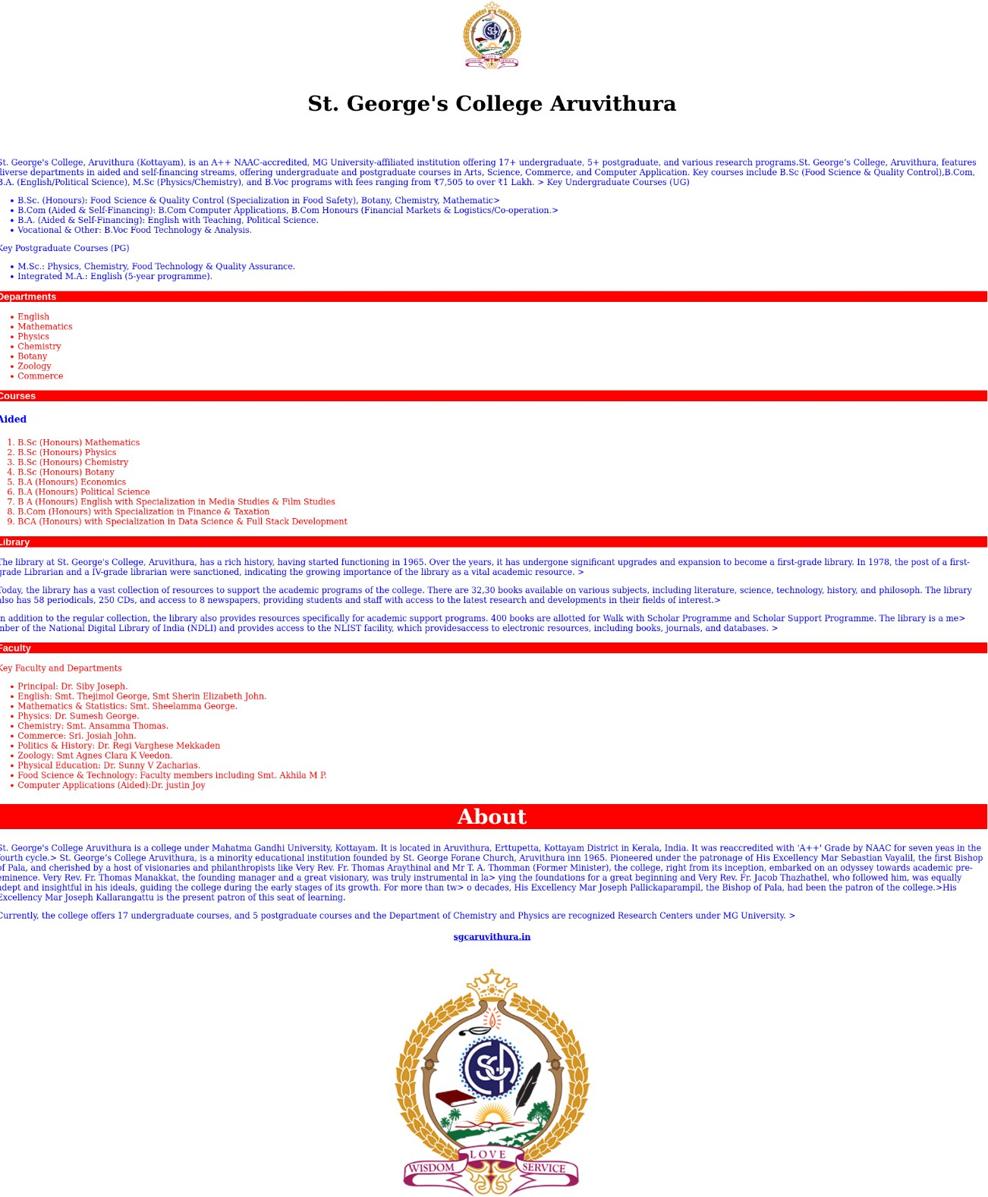

Program 8
Write a HTML Program to create your college website for Mobile device.

Aim.
Write a HTML Program to create your college website for Mobile device.

Program

<!DOCTYPE html>
<html>
<head>
<title>St George College</title>
<link rel="stylesheet" href="college.css">

<style>
.head{ color:white;
background-color:red;
font-family:arial,sans-serif;
}
h1{
font-size:40px;
}
</style>
<meta name="viewport" content="width=device-width,initial-scale=1.0">
</head>
<body>
<h3 align="center"><img src="sgc-college.png" width="150"></h3>
<h1 align="center" width="20">St. George's College Aruvithura</h1>
<br></br>
<p></p>
<p class="para">
St. George's College, Aruvithura (Kottayam), is an A++ NAAC-accredited, MG University- affiliated institution offering 17+ undergraduate, 5+ postgraduate, and various research programs.St. George’s College, Aruvithura, features diverse departments in aided and self- financing streams, offering undergraduate and postgraduate courses in Arts, Science, Commerce, and Computer Application. Key courses include B.Sc (Food Science & Quality Control),B.Com, B.A. (English/Political Science), M.Sc (Physics/Chemistry), and B.Voc programs with fees ranging from ₹7,505 to over ₹1 Lakh.</p>

Key Undergraduate Courses (UG)

<div class="para">

<ul>
<li>B.Sc. (Honours): Food Science & Quality Control (Specialization in Food Safety), Botany, Chemistry, Mathemati</li>
<li> B.Com (Aided & Self-Financing): B.Com Computer Applications, B.Com Honours (Financial Markets & Logistics/Co-operation</li>
<li> B.A. (Aided & Self-Financing): English with Teaching, Political Science.</li>
<li>Vocational & Other: B.Voc Food Technology & Analysis.</li>
</ul>
Key Postgraduate Courses (PG)
<ul>
<li>M.Sc.: Physics, Chemistry, Food Technology & Quality Assurance.</li>
<li>Integrated M.A.: English (5-year programme).</li>
</ul></p>
<h3 class="head">Departments</h3>
<p>
<ul class="point">
<li>English</li><li> Mathematics</li><li> Physics</li><li> Chemistry</li><li> Botany</li><li> Zoology</li><li> Commerce</li><li> Economics</li><li> Political Science</li><li> Computer Applications</li>
</p>
</ul></p>
<h3 class="head">Courses</h3>
<h5 class="h5">Aided</h5>
<ol class="point">
<li>B.Sc (Honours) Mathematics </li>

<li>B.Sc (Honours) Physics</li>

<li>B.Sc (Honours) Chemistry</li>

<li>B.Sc (Honours) Botany</li>

<li>B.A (Honours) Economics </li>

<li>B.A (Honours) Political Science </li>

<li>B A (Honours) English with Specialization in Media Studies & Film Studies </li>

<li>B.Com (Honours) with Specialization in Finance & Taxation</li>

<li>BCA (Honours) with Specialization in Data Science & Full Stack Development</li>
</ol>
<h3 class="head">Library</h3>

<p class="para">

The library at St. George's College, Aruvithura, has a rich history, having started functioning in 1965. Over the years, it has undergone significant upgrades and expansion to become a first-grade library. In 1978, the post of a first-grade Librarian and a IV-grade librarian were sanctioned, indicating the growing importance of the library as a vital academic resource.

<div>Today, the library has a vast collection of resources to support the academic programs of the college. There are 32,30 books available on various subjects, including literature, science, technology, history, and philosoph. The library also has 58 periodicals, 250 CDs, and access to 8 newspapers, providing students and staff with access to the latest research and developments in their fields of interest.</p>
<p>In addition to the regular collection, the library also provides resources specifically for academic support programs. 400 books are allotted for Walk with Scholar Programme and Scholar Support Programme. National Digital Library of India (NDLI) and provides access to the NLIST facility, which providesaccess to electronic resources, including books, journals, and databases.
</p>
</p>
<h3 class="head">Faculty</h3>
<div class="point">
Key Faculty and Departments
<ul>
<li> Principal: Dr. Siby Joseph.</li>
<li> English: Smt. Thejimol George, Smt Sherin Elizabeth John.</li>
<li> Mathematics & Statistics: Smt. Sheelamma George.</li>
<li> Physics: Dr. Sumesh George.</li>
<li> Chemistry: Smt. Ansamma Thomas.</li>
<li> Commerce: Sri. Josiah John.</li>
<li> Politics & History: Dr. Regi Varghese Mekkaden</li>
<li> Zoology: Smt Agnes Clara K Veedon.</li>
<li> Physical Education: Dr. Sunny V Zacharias.</li>

<li> Food Science & Technology: Faculty members including Smt. Akhila M P.</li>
<li> Computer Applications (Aided):Dr. justin Joy</li>
</ul>
</div>
<h1 class="about" align="center">About</h1>
<p class="para">St. George's College Aruvithura is a college under Mahatma Gandhi University, Kottayam. It is located in Aruvithura, Erttupetta, Kottayam District in Kerala, India. It was reaccredited with 'A++' Grade by NAAC for seven yeas in the fourth cycle.>
St. George’s College Aruvithura, is a minority educational institution founded by St. George Forane Church, Aruvithura inn 1965. Pioneered under the patronage of His Excellency Mar Sebastian Vayalil, the first Bishop of Pala, and cherished by a host of visionaries and philanthropists like Very Rev. Fr. Thomas Araythinal and Mr T. A. Thomman (Former Minister), the college, right from its inception, embarked on an odyssey towards academic pre-eminence. Very Rev. Fr. Thomas Manakkat, the founding manager and a great visionary, was truly instrumental in la>

ying the foundations for a great beginning and Very Rev. Fr. Jacob Thazhathel, who followed him, was equally adept and insightful in his ideals, guiding the college during the early stages of its growth. For more than tw>
o decades, His Excellency Mar Joseph Pallickaparampil, the Bishop of Pala, had been the patron of the college.>His Excellency Mar Joseph Kallarangattu is the present patron of this seat of learning.</p>
<p>Currently, the college offers 17 undergraduate courses, and 5 postgraduate courses and the Department of Chemistry and Physics are recognized Research Centers under MG University.</p>

<p><h4 align="center"><a href="sgcaruvithura.in">sgcaruvithura.in</a></h4>
</p>
<h3 align="center"><img src="sgc-college.png" width="500"></h3>
</body>
</html>

Output
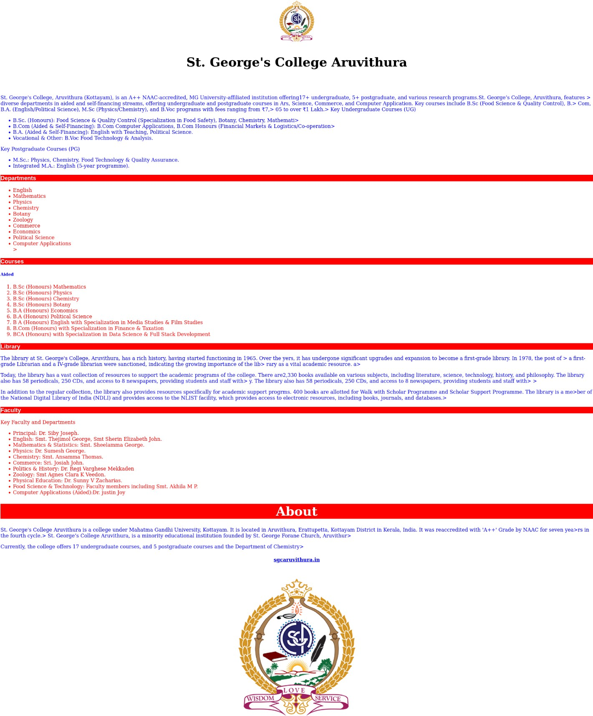

Program 9
Write an HTML/JavaScript page to create a login page with validators.

Aim.
Write an HTML/JavaScript page to create a login page with validators.

Program

<!DOCTYPE html>
<html>
<head>
</head>
<body>
Username:<input type="text" id="name"><br></br>
Password:<input type="text" id="password"><br></br>
<input type="button" value="Login" id="lgn" onclick="login()">
<script>
function login()
{

let user=document.getElementById("name").value;
let word=document.getElementById("password").value;
if(word.length>=4 && word.length<=8)
{
console.log("login succssefull!");
return "pass";
}
else
{
alert("password must have atleast 4 & maximum 8 characters");
console.log("fail");
}

if(user.length<=4)
{
alert("username must have atleast 4 character");
console.log("fail");
}
}
</script>
</body>
</html>

Output

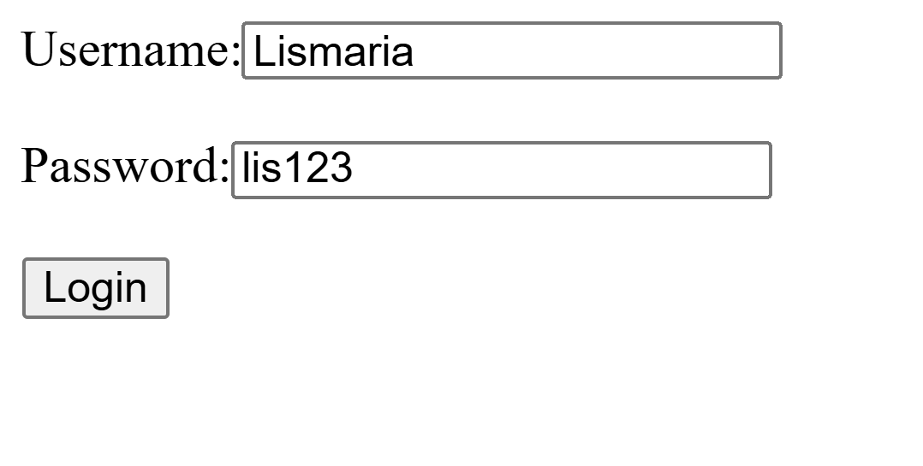

Program 10
Develop a simple calculator for addition, subtraction, multiplication, division operation using JavaScript.

Aim.
Develop a simple calculator for addition. Subtraction, multiplication,division operation using JavaScript.

Program

<!DOCTYPE html>
<html>
<head>
</head>
<body>

<h2 id="para" class="p">calculator</h2>
Number 1: <input type="number" value="number 1" id="num1"><br>
<p>Operator: <input type="text" value="" id="op"><br></p>
Number 2: <input type="number" value="number 2" id="num2"><br><p></p>
<input type="button" value="submit" onclick="calculator()"><br>

<p id="answer"></p>

<script>
function calculator()
{

let val1=document.getElementById("num1").value;

let val2=document.getElementById("num2").value;
let optr=document.getElementById("op").value;
switch(optr)
{
case "+":
document.getElementById("answer").innerHTML=Number(val1)+Number(val2);
braek;
case "-":
document.getElementById("answer").innerHTML=Number(val1)-Number(val2);
break;
case "*":
document.getElementById("answer").innerHTML=Number(val1)*Number(val2);
break;
case "/":
document.getElementById("answer").innerHTML=Number(val1)/Number(val2);
break;
}
}

</script>

</body>
</html>

Output

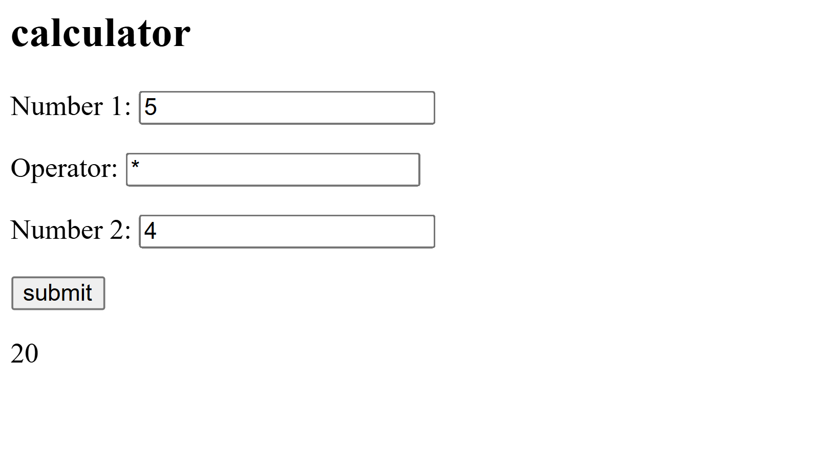

Program 11
Use Regular expressions for validations in login page using JavaScript.

Aim.
Use Regular expressions for validations in login page using JavaScript.

Program

<!DOCTYPE html>
<html>
<head>
</head>
<body>
<h3>Login Page</h2>
Username:<input type="text" id="name" placeholder="Enter your email"><br></br>
Password:<input type="text" id="password" ><br></br>
<input type="button" value="Login" id="login" onclick="duel()"></input>
<script>
function password()
{

let password=document.getElementById("password").value;
if(password.length<=6)
{
alert("password must have 6 character");
}
else
{
console.log("pass");
return "pass";
}
}
function username()
{
let username=document.getElementById("name").value;
let usernamepattern=/\w+@\w+\.\w+/;
if(!usernamepattern.test(username))
{
alert("invalid email");

}
else
{
console.log("pass");
return "pass";
}

}
function duel()
{
username();
password();
document.write("login succsseful!");
}
</script>
<body>

</body>
</html>

Output

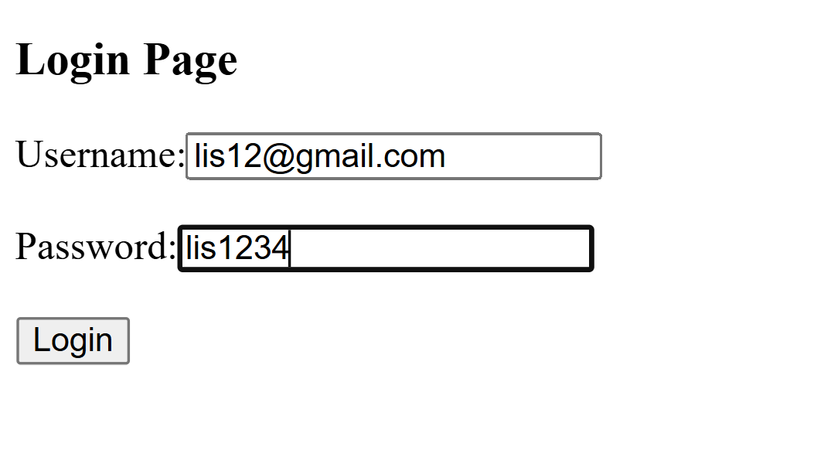


Program 12
Write a program to retrieve data from a text file and display it using AJAX.

Aim.

Write a program to retrieve data from a text file and display it using AJAX.

Program

